Sales Tax Activity

The reference application follows the patterns and practices we encourage in our software solutions we create. The software we write looks a lot like our reference application, but a big difference is our reference implementation uses the world’s most perfect user experience, a console application.

The ecommerce application isn’t a fully function ecommerce application, it is having many short cuts, so we can just demo the application. One of those short cuts is that the application doesn’t do a real sales tax calculation, it just does a flat 7% for all items.

In this walk through we will take you through modifying our reference application to support more a 3rd party tax library. We are playing pretty loose with the term 3rd party. We wrote a really basic library that does sales tax for the state of Nebraska. Now we won’t stand behind our tax library as production ready, but it is ready enough for the purpose of our reference implementation.

Now changing our reference application to support calling this 3rd party library will cause us to change our architecture. Before using this our architecture for adding an item to the shopping cart looked like below.

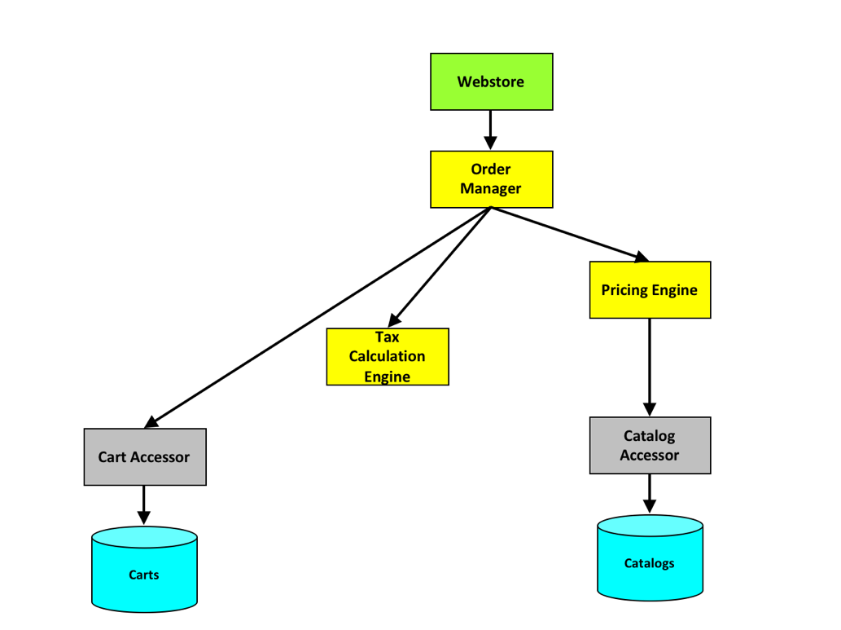

Changed to call our 3rd party library

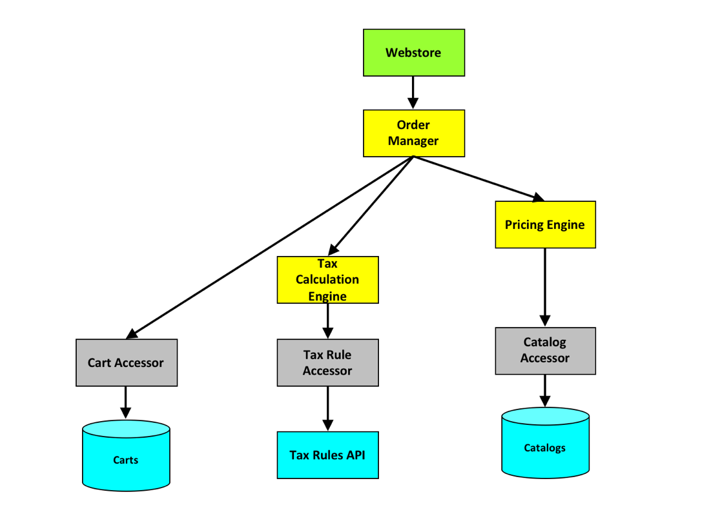

To make this change we will add a new accessor into our system, a SalesTaxRuleAccessor. This accessor will call our 3rd party library to get the sales tax. In a real system this would probably be a web call to another system.

We will have to load the USATaxer project into VisualStudio and build the library. That will create a USATaxer.dll. How does the USATaxer library work, well lets look at its unit test.

[TestMethod]

public void USATaxer_Initialized()

{

var taxer = new USATaxerLib();

taxer.Init();

Assert.AreEqual(0.0725m, taxer.Rate("68512"));

Assert.AreEqual(0.065m, taxer.Rate("68031"));

}

Copy the USATaxer.dll to the root of our ecommerce solution and add a reference to it in our Accessors project.

The next step here is to add a TaxRateAccessor to our solution. This will require us to add a new file, a TaxRateAccessor.cs file to be exact. We will add that file to the Accessor project.

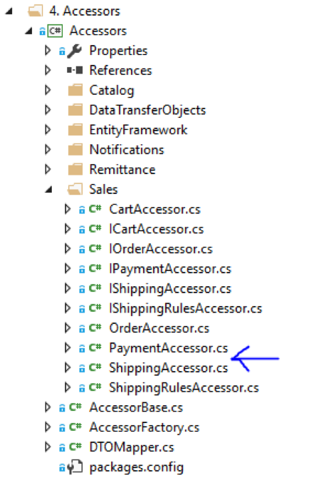

public interface ITaxRateAccessor : IServiceContractBase

{

decimal Rate(Address address);

}

class TaxRateAccessor : AccessorBase, ITaxRateAccessor

{

public decimal Rate(Address address)

{

USATaxer.USATaxerLib taxer = new USATaxer.USATaxerLib();

taxer.Init();

return taxer.Rate(address.Postal);

}

}

<https://gist.github.com/chadmichel/872eabad5bec6c434b6d33134149f34f>

The TaxRateAccessor needs to be wired up into our dependency injection system. To do that we need to modify our AccessorFactory.cs file. In our reference implementation we are doing all the dependency injection ourselves. In many production systems we may using something like unity to use dependency injection, but in our reference implementation we wanted to keep things simple.

public AccessorFactory(AmbientContext context, UtilityFactory utilityFactory) : base(context)

{

// NOTE: this is here to ensure the factories from the Manager are propogated down to the other factories

_utilityFactory = utilityFactory ?? new UtilityFactory(Context);

AddType<ICartAccessor>(typeof(CartAccessor));

AddType<ICatalogAccessor>(typeof(CatalogAccessor));

AddType<IEmailAccessor>(typeof(EmailAccessor));

AddType<IOrderAccessor>(typeof(OrderAccessor));

AddType<IEmailAccessor>(typeof(EmailAccessor));

AddType<IPaymentAccessor>(typeof(PaymentAccessor));

AddType<IShippingAccessor>(typeof(ShippingAccessor));

AddType<ISellerAccessor>(typeof(SellerAccessor));

AddType<IRemittanceAccessor>(typeof(RemittanceAccessor));

AddType<IShippingRulesAccessor>(typeof(ShippingRulesAccessor));

AddType<ITaxRateAccessor>(typeof(TaxRateAccessor));

}

<https://gist.github.com/chadmichel/fcf17e464d3aa8c52560e8f106b3ad6c>

At this point we have a new accessor, and it should be supported by our DI framework. All that is left would be to use it. But wait, we should test it first. To do that we will add a new framework.

Now that we have a test (and hopefully it passes) we can finally use this accessor in our code. To do this we will have to change our TaxCalculationEngine. This can be found in the TaxCalculationEngine.cs file in the Engine project.

public WebStoreCart CalculateCartTax(WebStoreCart cart)

{

if (cart != null && cart.BillingAddress != null && !string.IsNullOrWhiteSpace(cart.BillingAddress.Postal))

{

var taxRate =

AccessorFactory.CreateAccessor<ITaxRateAccessor()

.Rate(cart.BillingAddress);

foreach (var item in cart.CartItems)

{

cart.TaxAmount += Math.Round(item.ExtendedPrice * taxRate, 2);

// just assuming 7% tax for everything for now

}

// update the cart total with the tax amount

cart.Total += Math.Round(cart.TaxAmount, 2);

}

return cart;

}

<https://gist.github.com/chadmichel/8dc21cecb2c84c462cbef259d86df544>

Now after wiring in to use this new SalesTaxRuleAccessor something will happen. We will break some unit tests. Now this is okay because we have changed out taxes are calculated. Go through and update the unit tests to use what we are now calculating for tax.

This activity shows how to extend our existing reference implementation by calling a 3rd party library to do sales tax calculations. This example also shows how volatility-based decomposition helps to prevent a simple change from exploding through all of the source. The only existing code that changed was the TaxCalculationEngine.